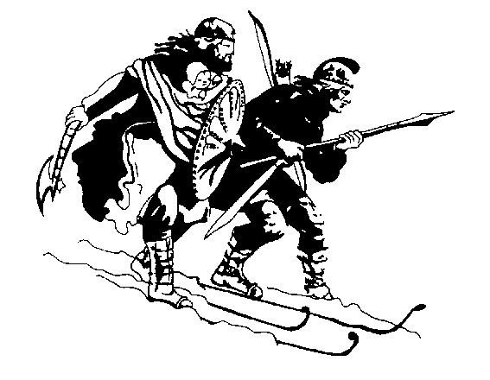
Birkebeiner Nordic Ski Club Inc.
PO Box 192, Mount Beauty 3699
Mobile: 0431 248 298

Secretary’s email: secretary@birkebeiner.org.au
Website: www.birkebeiner.org.au

National Team Member Grant Application
Please complete this form by typing into it and email it to the secretary as an attachment <weegie@live.com.au> or post to the address above. Applications close on October 8.
Name
Postal address
Postcode
Phone Mobile
Date of birth I have been a BNSC member for years.
Your Team/Squad
Email (Please print clearly!)
Do you agree to provide a one page trip report for the Bulletin on your return?
Date: …………………………………
Please include a one to two page application which includes the following:
1. Your trip details and goals
2. Whether you are participating in a team trip or going it alone on an approved program (or a combination)
3. Outline the major competitions you will be entering
4. Personal budget including any other grants or funding you expect to receive (Please attach on a separate page if necessary)
5. What other funding or sponsorship will you receive?
Note: Applications close on 8th October. All applications will be acknowledged by email. If you don’t receive an acknowledgement, please ring Secretary — Ronice Goebel Mob: 0409 332 642 to confirm that your application was received. The club takes no responsibility for undelivered applications, and late applications will not be accepted.

